**LAN Chat Application**

------------------------------------------------------------***----------------------------------------------------------------

**Abstract: -** The LAN Chat Application uses methodology provides low-cost communication between staff & an organization. In this process, it enables users to, chat and upload small to medium-sized files. The chat conversations and quick file transfers are made through LCS which minimizes the communication issues, which are mainly time and cost of communication and maintenance. Object oriented programming was used to develop the LCS system and the programming language utilized was JAVA, focused on the implementation of two-tier architecture within TCP/IP. The system was implemented based on a standalone application using pure object oriented language. This system was successfully tested.

# Introduction

LAN Chat Server (LCS) is a chat system via local area network. The functions of the system include chat room & files uploading. The bulk of people who used local area networks nowadays put in force security procedures at their limits. The procedures are generally designed to succeed at least two aims. First, they attempt to limit the harm to the network that valid clients may cause, for example, by mistakably downloading virus infected emails or by permeable secret business information to the outdoor world. Second, network edge security strategies can limit or sometimes eradicate difficulties produced by worms and other types of malware.

# Two-Tier Architecture

The LCM (LAN Chat Messenger) uses two-tier client server architecture as shown in figure 1. The application handling is completed separately for user interface presentation. Generally, the networks bind the back-end of an application to the front-end, though all tiers can be present on the same hardware. The architecture of any client/server situation is by classification at least a two-tier system, the client is the first tier and the server is the second.

The two-tier design generally encompasses client demanding services undeviating from server i.e. client communicates alongside the server without the help of another server or server process.

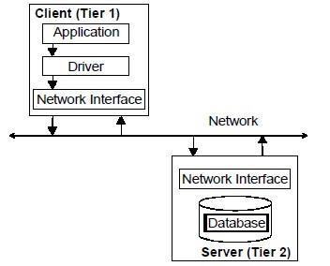

**Figure 1:** Two Tier Client/Server Architecture Model

## How Chat Communications Work

Two sockets are created at the client side and the server side. The client connects to the server through its IP address and port number. They must share the same port number for them to communicate. The client and the server both communicate through a stream of bytes written to the socket. The client and the server must agree on a protocol (TCP, UDP or RAW) and agree on the language of the information transferred back and forth through the socket. This study used socket concept to collect message. Basically, the message sent by one client into a socket and passes it to another client on the receiving side. If it is group chatting, a central socket will be used to collect the message and then it will be broadcast to all clients that are active.

# System Implementation

The system was implemented using JAVA programming.

# Conclusions and Discussion

The LCM is established as a solution to some communication problems and reduces the use of resources including time factor of an organization’s internal communication. The proposed system enables users to communicate on networks outside internet boundaries. LCM can be integrated in other application areas such as in school, university and public libraries for communication between library patrons and librarian, in business offices, scientific organizations, and the academe, to mention a few. The proposed system can be a future replacement for many internet chat applications and will cost the organization lesser resources to implement. The strengths of the system identified are: more communication opportunities within an organization without using an internet subscription; it can work on all Windows platforms provided that the client and server are using the same type of operating system; it enables connected clients to chat with each other & upload files; it supports peer-to-peer and server-based modes; user interface is common and familiar; and users may create chat rooms for specific topics or users so if there is any urgent management announcement is easy to broadcast to everyone at once and to specific persons only. There are other advantages of the system especially when future enhancements would be analysed and implemented.

Name : Mirza Iliyaz Baig

Roll No. : 1604-18-737-308

Contact : 9391236969